Netherton J&I
Long term plan
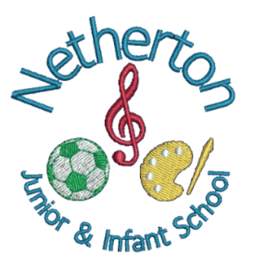
Science
Curriculum
Overview
 | Autumn 1st Half | Autumn 2nd Half | Spring 1st Half | Spring 2nd Half | Summer 1st Half | Summer 2nd Half
EYFS | Regulate Me | Let’s Celebrate | Real or Not Real | Twisted Tales & Traditional Tales | Wonderful World | Wonderful Water
Year 1 | What’s It Made of?  (EVERYDAY MATERIALS) |  | Amazing Me!  (Humans) | Going Wild  (ANIMALS) |  | How Does Your Garden Grow?  (PLANTS)
Year 2 | Fit For Success (ANIMALS INC HUMANS) | Uses of everyday materials |  | Living things and their habitat | Roots, Shoots & Juicy Fruits  (PLANTS)
Year 3 | Food, Glorious Food  (ANIMALS INC HUMANS) | Rock & Roll (ROCKS & SOILS) | May The Force Be With You  (FORCES) |  | Shine!  (LIGHT) | Ready, Set, Grow (PLANTS)
Year 4 | No Place Like Home (LIVING THINGS AND THEIR HABITATS) | Making Waves  (SOUND) | A Little Bit Gassy (STATES OF MATTER) | What’s the Buzz? (ELECTRICITY) | Burps, Bottoms & Bile (DIGESTIVE SYSTEM & TEETH)
Year 5 | Great British Scientists | Man On the Moon  (EARTH & SPACE) | It’s Going To Get Messy! (PROPERTIES & CHANGES IN MATERIALS) | May The Force Be With You  (FORCES) | It’s Good To Be Me  (LIVING THINGS & THEIR HABITATS) | Life Explorers  (ANIMALS INC HUMANS)
Year 6 | Odd One Out  (LIVING THINGS & THEIR HABITATS) | A Game Of Survival  (EVOLUTION & INHERITANCE) | Fighting Fit  (ANIMALS INC HUMANS) | Blinding Lights  (LIGHT) |  | Bright Sparks  ELECTRICTY

Early Years | Autumn 1st | Autumn 2nd | Spring 1st | Spring 2nd | Summer 1st | Summer 2nd
Overview | Regulate Me | Let’s Celebrate | Real or Not Real | Twisted Tales & Traditional Tales | Wonderful World | Wonderful Water
I can statements | In this unit children will learn to:  - I can explore animal habitats  - I can explore living spaces | In this unit children will learn to:  - I can explore light and dark  - I can describe shadows  - I can notice changes outside  - I can describe what I observe outdoors  . | In this unit children will learn to:  - I can melt ice  - I can say how things have changed | In this unit children will learn to-  - I can test materials to tell you what is best for building  - I can explain strong and weak  - I can compare habitats  - I can explain what I notice about sound  - I can choose healthy foods  - I can test materials  - I can observe how a plant grows | In this unit children will learn to-  - I can care for living things  - I can explain simple life processes like eating or hunting  - I can talk about where food comes from  - I can express ideas about nature  - I can describe what I hear  - I can see how materials change  - I can describe changes over time | In this unit children will learn to-  - I can describe what I observe and how a plant grows  - I can compare and contrast different places  - I can talk about the seasons

Year 1
Overview | What’s It Made Of?  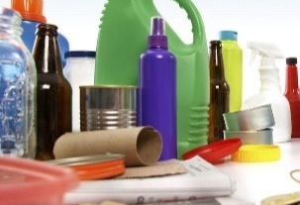 | Amazing Me!  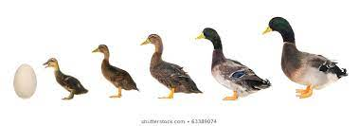 | Going Wild?  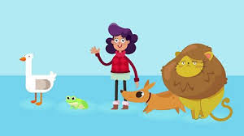 | How Does Your Garden Grow?  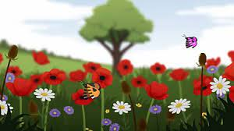
Aspects | In this unit children will learn to:  -To observe and name the changing seasons.  -To explore seasonal change within our environment, moving from summer into autumn.  -To monitor and identify weather patterns.  Year 1: To identify, name, sort and discuss the properties of everyday materials. | In this unit children will learn to:  -To observe and name the changing seasons.  -To explore seasonal change within our environment, moving from Winter into Spring.  Year 1: To identify the parts of the body, how they work, what they are used for and how to keep them healthy.  To look closely at the body parts that are associated with our senses.  To carry out a range of experiments that test our senses. | In this unit children will learn to-  -To observe and name the changing seasons.  -To explore seasonal change within our environment, moving from Spring to Summer  Year 1:To identify and name a variety of common animals including fish, amphibians and minibeasts.  To describe and compare the structure of a variety of common animals (fish, amphibians, humans and minibeasts)  To investigate the conservation of animals in the wild and in zoos. | In this unit children will learn to-  -To observe and name the changing seasons.  -To explore seasonal change within our environment, moving from Winter into Spring  Year 1: To identify and name a variety of common wild and garden plants, including deciduous and evergreen trees.  To identify and describe the basic structure of a variety of common flowering plants, including trees.
Key Vocabulary | Object, material, wood, plastic, glass, metal, water, rock, brick, paper, fabric, elastic, foil, card/cardboard, rubber, wool, clay, hard, soft, stretchy, stiff, bendy, floppy, waterproof, absorbent, breaks/tears, rough, smooth, shiny, dull, see through, not see through, | Head, body, eyes, ears, mouth, teeth, leg, tail, wing, claw, fin, scales, feathers, fur, beak, paws, hooves, Senses, touch, see, smell, taste, hear, fingers (skin), eyes, nose, ear and tongue | Living, dead, never been alive, suited, suitable, basic needs, food, food chain, shelter, move, feed, names of local habitats e.g. pond, woodland etc., names of micro-habitats e.g. under logs, in bushes etc. | Leaf, flower, blossom, petal, fruit, berry, root, seed, trunk, branch, stem, bark, stalk, bud, light, shade, sun, warm, cool, water, grow, healthy
Year 2
Overview | Fit For Success!  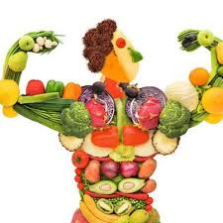 | Uses of Everyday Materials  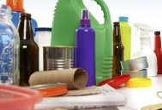 | Living Things and their habitats | Roots, Shoots & Juicy Fruits  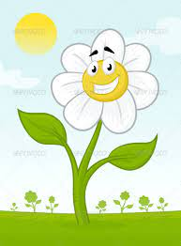
Aspects | In this unit children will learn to:  To notice that animals, including humans, have offspring which grow into adults  To explore and compare the differences between things that are living, dead, and things that have never been alive. To find out about and describe the basic needs of animals, including humans, for survival (water, food and air)  To describe the importance for humans of exercise, eating the right amounts of different types of food, and hygiene  To describe how animals, obtain their food from plants and other animals, using the idea of a simple food chain, and identify and name different sources of food. | In this unit children will learn to:  Year 2: To investigate that suitability, properties and uses of everyday materials.  To begin to explore how materials can be changed.  To identify and compare the suitability of a variety of everyday materials for particular uses.  To find out about how the shape of solid objects made from some materials can be changed by squashing, bending, twisting and stretching | In this unit children will learn to: Year 2:To Identify that most living things live in habitats to which they are suited and describe how different habitats provide for the basic needs of different kinds of animals and how they depend on each other.  To Identify and name a variety of plants and animals in their habitats, including microhabitats. | In this unit children will learn to-  Year 2: To identify and name a variety of plants.  To investigate a range of plant types and their habitats and what makes them suitable for growth.  To observe and describe how seeds and bulbs grow into mature plants.  To find out and describe how plants need water, light and a suitable temperature to grow and stay healthy.
Key Vocabulary | Offspring, reproduction, growth, child, young/old stages (examples - chick/hen, baby/child/adult, caterpillar/butterfly), exercise, heartbeat, breathing, hygiene, germs, disease, food types (examples – meat, fish, vegetables, bread, rice, pasta) | stretchy, stiff, bendy, floppy, waterproof, absorbent, breaks/tears, rough, smooth, shiny, dull, see through, not see through, | Habitats, living, alive, jungle, desert, woodland, polar region, suited to, savannah, dead, micro habitat, pond, animals, plants, food chain. | Leaf, flower, blossom, petal, fruit, berry, root, seed, trunk, branch, stem, bark, stalk, bud, light, shade, sun, warm, cool, water, grow, healthy  Photosynthesis, pollen, insect/wind pollination, seed formation, seed dispersal – wind dispersal, animal dispersal, water dispersal
Year 3
Overview | Rock and Roll  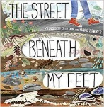 | Shine!  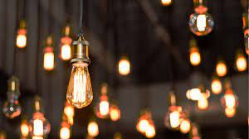 | May the Force Be With You  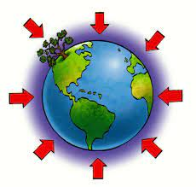 | Ready, Set, Grow!  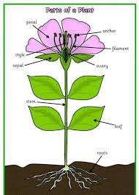 | Food, Glorious Food  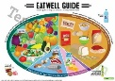
Aspects | In this unit children will learn to:  To recognise that soils are made from rocks and organic matter  associate the rate of evaporation with temperature.  To compare and group together different kinds of rocks on the basis of their appearance and simple physical properties  Describe in simple terms how fossils are formed when things that have lived are trapped within rock. | In this unit children will learn to:  To recognise that they need light in order to see things and that dark is the absence of light  Notice that light is reflected from surfaces  To recognise that light from the sun can be dangerous and that there are ways to protect their eyes  Recognise that shadows are formed when the light from a light source is blocked by an opaque object  Find patterns in the way that the size of shadows change | In this unit children will learn to:  To compare how things move on different surfaces.  Notice that some forces need contact between two objects, but magnetic forces can act at a distance.  Observe how magnets attract or repel each other and attract some materials and not others  Compare and group together a variety of everyday materials on the basis of whether they are attracted to a magnet, and identify some magnetic materials.  Describe magnets as having two poles  predict whether two magnets will attract or repel each other, depending on which poles are facing. | In this unit children will learn to:  To identify and describe the functions of different parts of flowering plants: roots, stem/trunk, leaves and flowers  To explore the requirements of plants for life and growth (air, light, water, nutrients from soil, and room to grow) and how they vary from plant to plant  To investigate the way in which water is transported within plants  To explore the part that flowers play in the life cycle of flowering plants, including pollination, seed formation and seed dispersal | To identify that animals, including humans, need the right types and amount of nutrition, and that they cannot make their own food; they get nutrition from what they eat  To identify that humans and some other animals have skeletons and muscles for support, protection and movement
Key Vocabulary | Rock, stone, pebble, boulder, grain, crystals, layers, hard, soft, texture, absorb water, soil, fossil, marble, chalk, granite, sandstone, slate, soil, peat, sandy/chalk/clay soil | Light, light source, dark, absence of light, transparent, translucent, opaque, shiny, matt, surface, shadow, reflect, mirror, sunlight, dangerous | Force, push, pull, twist, contact force, non-contact force, magnetic force, magnet, strength, bar magnet, ring magnet, button magnet, horseshoe magnet, attract, repel, magnetic material, metal, iron, steel, poles, north pole, south pole | Leaf, flower, blossom, petal, fruit, berry, root, seed, trunk, branch, stem, bark, stalk, bud, light, shade, sun, warm, cool, water, grow, healthy  Photosynthesis, pollen, insect/wind pollination, seed formation, seed dispersal – wind dispersal, animal dispersal, water dispersal | food types (examples – meat, fish, vegetables, bread, rice, pasta)  Nutrition, nutrients, carbohydrates, sugars, protein, vitamins, minerals, fibre, fat, water, skeleton, bones, muscles, support, protect, move, skull, ribs, spine, muscles, joints
Year 4
Overview | No Place Like Home  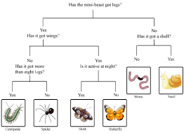 | Making Waves  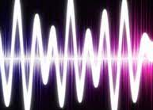 | It’s A Bit Gassy  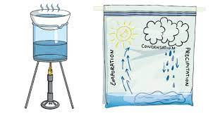 | Burps, Bottoms & Bile?  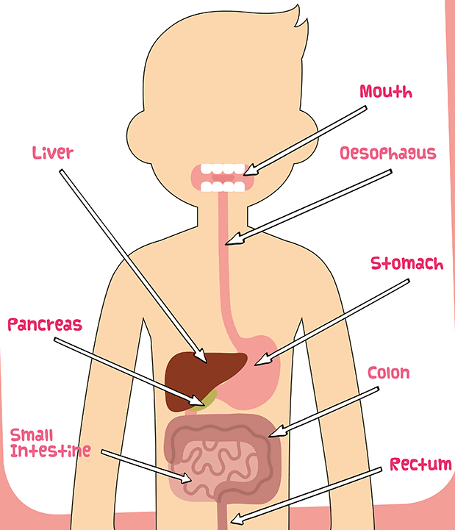 | What’s The Buzz?  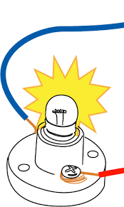
Aspects | In this unit children will learn to:  To recognise that living things can be grouped in a variety of ways  Explore and use classification keys to help group, identify and name a variety of living things in their local and wider environment  Recognise that environments can change and that this can sometimes pose dangers to living things | In this unit children will learn to:  To identify how sounds are made, associating some of them with something vibrating  To recognise that vibrations from sounds travel through a medium to the ear  Find patterns between the pitch of a sound and features of the object that produced it  To find patterns between the volume of a sound and the strength of the vibrations that produced it  Recognise that sounds get fainter as the distance from the sound source increases | In this unit children will learn to  Compare and group materials together, according to whether they are solids, liquids or gases  Observe that some materials change state when they are heated or cooled, and measure or research the temperature at which this happens in degrees Celsius (°C)  To identify the part played by evaporation and condensation in the water cycle and associate the rate of evaporation with temperature | In this unit children will learn to:  Describe the simple functions of the basic parts of the digestive system in humans  identify the different types of teeth in humans and their simple functions  Construct and interpret a variety of food chains, identifying producers, predators and prey  Digestive system, digestion, mouth, teeth, saliva, oesophagus, stomach, small intestine, nutrients, large intestine, rectum, anus, teeth, incisor, canine, molar, premolars, herbivore, carnivore, omnivore, producer, predator, prey, food chain | In this unit children will learn to:  To identify common appliances that run on electricity  Construct a simple series electrical circuit, identifying and naming its basic parts, including cells, wires, bulbs, switches and buzzers  To identify whether or not a lamp will light in a simple series circuit, based on whether or not the lamp is part of a complete loop with a battery  To recognise that a switch opens and closes a circuit and associate this with whether or not a lamp lights in a simple series circuit  Recognise some common conductors and insulators, and associate metals with being good conductors
Key Vocabulary | Classification, classification keys, environment, habitat, human impact, positive, negative, migrate, hibernate | Sound, source, vibrate, vibration, travel, pitch (high, low), volume, faint, loud, insulation | soil, peat, sandy/chalk/clay soil,  Solid, liquid, gas, state change, melting, freezing, melting point, boiling point, evaporation, temperature, water cycle |  | Electricity, electrical appliance/device, mains, plug, electrical circuit, complete circuit, component, cell, battery, positive, negative, connect/connections, loose connection, short circuit, crocodile clip, bulb, switch, buzzer, motor, conductor, insulator, metal, non-metal, symbol
5
Year 5
 | Autumn 1st | Autumn 2nd | Spring 1st Spring 2nd | Summer 1st | Summer 2nd
Overview | Man On the Moon   | It’s Going to Get Messy!   | May the Force Be With You | It’s Good To Be Me  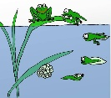 | Life Explorers  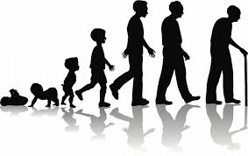
Aspects | In this unit children will learn to:  To describe the movement of the Earth, and other planets, relative to the Sun in the solar system  Describe the movement of the Moon relative to the Earth  To describe the Sun, Earth and Moon as approximately spherical bodies  To use the idea of the Earth’s rotation to explain day and night and the apparent movement of the sun across the sky | In this unit children will learn to:  Compare and group together everyday materials on the basis of their properties, including their hardness, solubility, transparency, conductivity (electrical and thermal), and response to magnets  To know that some materials will dissolve in liquid to form a solution, and describe how to recover a substance from a solution  Use knowledge of solids, liquids and gases to decide how mixtures might be separated, including through filtering, sieving and evaporating  Give reasons, based on evidence from comparative and fair tests, for the particular uses of everyday materials, including metals, wood and plastic  Demonstrate that dissolving, mixing and changes of state are reversible changes  Explain that some changes result in the formation of new materials, and that this kind of change is not usually reversible, including changes associated with burning and the action of acid on bicarbonate of soda | In this unit children will learn to:  Explain that unsupported objects fall towards the Earth because of the force of gravity acting between the Earth and the falling object  To identify the effects of air resistance, water resistance and friction, that act between moving surfaces  Recognise that some mechanisms, including levers, pulleys and gears, allow a smaller force to have a greater effect | In this unit children will learn to:  Describe the differences in the life cycles of a mammal, an amphibian, an insect and a bird  To describe the life process of reproduction in some plants and animals | In this unit children will learn to:  To describe the changes as humans develop to old age  (Links here with Living Things and Their Habitats and RSE: Changing Me)
Key Vocabulary | Earth, Sun, Moon, (Mercury, Jupiter, Saturn, Venus, Mars, Uranus, Neptune) spherical, solar system, rotates, star, orbit, planets | Thermal/electrical insulator/conductor, change of state, mixture, dissolve, solution, soluble, insoluble, filter, sieve reversible/non-reversible change, burning, rusting, new material | Force, gravity, Earth, air resistance, water resistance, friction, mechanisms, simple machines, levers, pulleys, gears | Life cycle, reproduce, sexual, sperm, fertilises, egg, live young, metamorphosis, asexual, plantlets, runners, bulbs, cuttings | Puberty: the vocabulary to describe sexual characteristics

Year 6
 | Autumn 1st | Autumn 2nd | Spring 1st | Spring 2nd | Summer 1st | Summer 2nd
Overview | Odd One Out  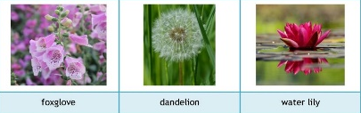 | A Game Of Survival  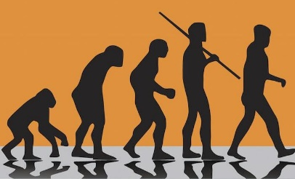 | Fighting Fit   | Blinding Lights   |  | Bright Sparks  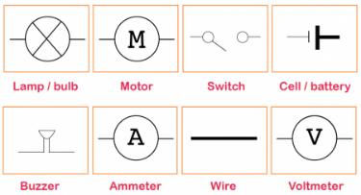
Aspects | In this unit children will learn to:  Describe how living things are classified into broad groups according to common observable characteristics and based on similarities and differences, including micro-organisms, plants and animals  Give reasons for classifying plants and animals based on specific characteristics | In this unit children will learn to:  Recognise that living things have changed over time and that fossils provide information about living things that inhabited the Earth millions of years ago  To recognise that living things produce offspring of the same kind, but normally offspring vary and are not identical to their parents  Identify how animals and plants are adapted to suit their environment in different ways and that adaptation may lead to evolution | In this unit children will learn to:  Identify and name the main parts of the human circulatory system, and describe the functions of the heart, blood vessels and blood  Recognise the impact of diet, exercise, drugs and lifestyle on the way their bodies function  To describe the ways in which nutrients and water are transported within animals, including humans | In this unit children will learn to:  Recognise that light appears to travel in straight lines  To use the idea that light travels in straight lines to explain that objects are seen because they give out or reflect light into the eye  Explain that we see things because light travels from light sources to our eyes or from light sources to objects and then to our eyes  To use the idea that light travels in straight lines to explain why shadows have the same shape as the objects that cast them |  | In this unit children will learn to:  To associate the brightness of a lamp or the volume of a buzzer with the number and voltage of cells used in the circuit  Compare and give reasons for variations in how components function, including the brightness of bulbs, the loudness of buzzers and the on/off position of switches  To use recognised symbols when representing a simple circuit in a diagram
Key Vocabulary | Vertebrates, fish, amphibians, reptiles, birds, mammals, invertebrates, insects, spiders, snails, worms, flowering and non-flowering | Offspring, sexual reproduction, vary, characteristics, suited, adapted, environment, inherited, species, fossils | Heart, pulse, rate, pumps, blood, blood vessels, transported, lungs, oxygen, carbon dioxide, nutrients, water, muscles, cycle, circulatory system, diet, exercise, drugs and lifestyle | As for Year 3 plus-  Straight lines, light rays, prism, brightness |  | Circuit, complete circuit, diagram, symbol, cell, battery, bulb, buzzer, motor, switch, voltage

