Netherton J&I
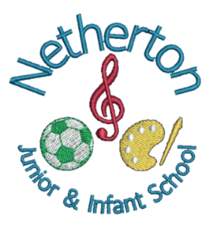

RE
Long term plan

Overview
 | RE 1 | RE 2 | RE 3 | RE 4
Year 1 | Who is A Christian and what do they believe?  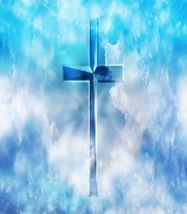 | How and why do we celebrate special and sacred times?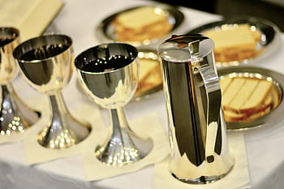 | 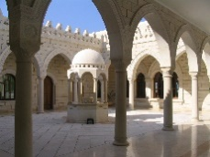  What makes some places sacred?  ? | What does it mean to belong to a faith community?
Year 2 | Who is a Muslim and what do they believe?  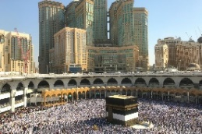 | How should we care for others in the world and why does it matter?  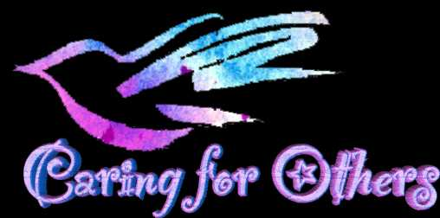? | Who is a Muslim and what do they believe part 2  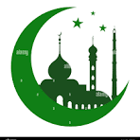 | Who is Jewish and what do they believe?  
Year 3 | What does it mean to be a Christian in Britain today?? | Why is Jesus inspiring to some people?  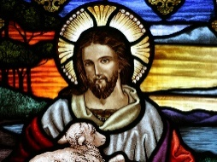 | What can we learn about deciding what is right and wrong?  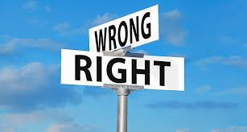 |   What does it mean to be a Hindu today
Year 4 | What do different people believe about God?  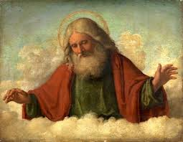 | What is the Bible important to Christians today 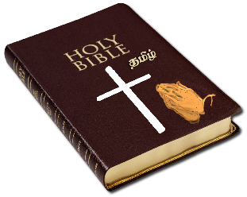 | 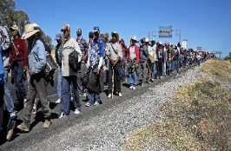  Why do some people think that life is a journey? | Why are festivals important to religious communities?  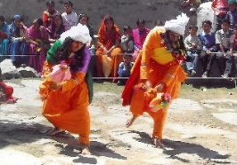
Year 5 | Why do some people believe God exists?  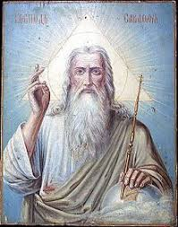 | What would Jesus do? | If God is everywhere, why go to places of worship? | What does it mean to be a Muslim in Britain today?
Year 6 | What matters most to Christians and Humanists?  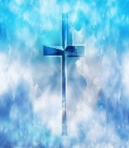 | 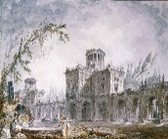  Is it better to express your religion through art and architecture or charity and generosity? | What difference does it make to believe in Ahimsa, Grace and Ummah?   | What can be done to reduce racism Can religion help?  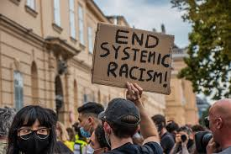

Year 1
 | RE 1 | RE 2 | RE 3 | RE 4
Overview | 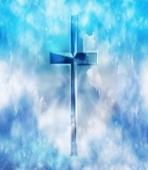  Who is a Christian and what do they believe? | 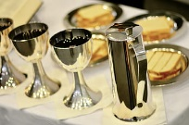  How and why do we celebrate special and sacred times? | 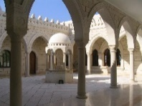  What makes some places sacred? | What does it mean to belong to a faith community?  
Aspects | In this unit children will learn to:  . Talk about the fact that Christians believe in God and follow the example of Jesus.  . Recognise some Christian symbols and images used to express ideas about God.  . Talk about some simple ideas about Christian beliefs about God and Jesus.  . Re-tell a story that shows what Christians might think about God, in words, drama and pictures, suggesting what it means.  . Talk about issues of good and bad, right and wrong arising from the stories.  . Ask some questions about believing in God and offer some ideas of their own.  . Make links between what Jesus taught and what Christians believe and do. | In this unit children will learn to:  . Identify a special time they celebrate and explain simply what celebration means.  . Talk about ways in which Jesus was a special person who Christians believe is the Son of God.  . Identify some ways Christians celebrate. Christmas/Easter/Harvest/Pentecost and some ways a festival is celebrated in another religion.  . Re-tell stories connected with Christmas/Easter/Harvest/Pentecost and a festival in another religion and say why these are important to believers.  . Ask questions and suggest answers about stories to do with Christian festivals and a story from a festival in another religion.  . Collect examples of what people do, give, sing, remember or think about at the religious celebrations studied, and say why they matter to believers.  . Suggest meanings for some symbols and actions used in religious celebrations, including Easter/Christmas, Chanukah and/or Eid-ul-Fitr.  . Identify some similarities and differences between the celebrations studied.  about what happens in a church, synagogue or mosque.  . Suggest meanings to religious songs, responding sensitively to ideas about thanking and praising. | In this unit children will learn to:  . Recognise that there are special places where people go to worship, and talk about what people do there.  . Identify at least three objects used in worship in two religions.  . Identify special objects and symbols found in a place where people worship and be able to say something about what they mean and how they are used  . Talk about ways in which stories, objects, symbols and actions used in churches, mosques and/or synagogues show what people believe.  . Describe some of the ways in which people use music in worship, and talk about how different kinds of music makes them feel.  . Ask good questions during a school visit | In this unit children will learn to:  . Talk about what is special and of value about belonging to a group that is important to them.  . Show an awareness that some people belong to different religions.  . Recognise and name some symbols of belonging from their own experience, for Christians and at least one other religion, suggesting what these might mean and why they matter to believers.  . Give an account of what happens at a traditional Christian infant baptism /dedication and suggest what the actions and symbols mean.  . Identify two ways people show they belong to each other when they get married.  . Respond to examples of co-operation between different people.  . Give examples of ways in which believers express their identity and belonging within faith communities, responding sensitively to differences.  . Identify some similarities and differences between the ceremonies studied
Key Vocabulary | Bible  God  Old Testament  New Testament  prayer  revelation  sacred  symbol  worship | Chanukah  Christmas  disciples  Easter  Eid-ul-Fitr  Good Friday  Palm Sunday  Shabbat  Sukkot  Pesach | altar  artefacts  calligraphy  church  font  holy  lectern  mihrab  minbar  Mosque  precious  pulpit  respect  worship | baptism  belonging  ceremony  christening  Christian  community  Muslim  Promise  Symbol  wedding
RE Skills

Investigation – this includes: asking relevant questions.
Reflection – this includes: the ability to reflect on feelings, experience, attitudes, beliefs, values, relationships, practices and ultimate questions.
Empathy – this includes: developing the power of imagination to identify feelings such as love, wonder, forgiveness and sorrow; the ability to consider the thoughts, feelings, experiences, attitudes, beliefs and values of others; the ability to see the world through the eyes of others, and to see issues from their point of view.
Expression – this includes: the ability to articulate ideas, beliefs and values; the ability to respond to religious ideas, beliefs and questions through a variety of media.
Self-understanding – this includes: the ability to draw meaning from significant experiences in their own and others’ lives and from religious questions and answers.

Year 2
 | RE 1 | RE 2 | RE 3 | RE 4
Overview | 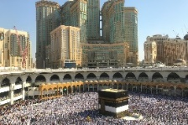  Who is a Muslim and what do they believe?  Part one | How should we care for others in the world and why does it matter? | Who is a Muslim and what do they believe ?  Part two | Who is Jewish and what do they believe?
Aspects | In this unit children will learn to:  . Talk about the fact that Muslims believe in God (Allah) and follow the example of the Prophet Muhammad identify some ways Muslims mark Ramadan and celebrate Eid-ul-Fitr.  . Recognise that Muslims do not draw Allah or the Prophet, but use calligraphy to say what God is like.  . Talk about some simple ideas about Muslim beliefs about God, making links with some of the 99 Names of Allah.  . Re-tell a story about the life of the Prophet Muhammad.  . Recognise some objects used by Muslims and suggest why they are important.  . Identify some ways Muslims mark Ramadan and celebrate Eid-ul-Fitr and how this might make them feel.  . Make links between what the Holy Qur’an says and how Muslims behave. | In this unit children will learn to:  . Talk about how religions teach that people are valuable, giving simple examples.  . Recognise that some people believe God created the world and so we should look after it.  . Re-tell Bible stories and stories from another faith about caring for others and the world.  . Identify ways that some people make a response to God by caring for others and the world.  . Talk about issues of good and bad, right and wrong arising from the stories.  . Talk about some texts from different religions that promote the ‘Golden Rule’, and think about what would happen if people followed this idea more.  . Use creative ways to express their own ideas about the creation story and what it says about what God is like.  . Answer the title question thoughtfully, in the light of their learning in this unit. | In this unit children will learn to:  In Islam there is only one God, Allah and someone who follows the religion of Islam is a Muslim. The Shahadah, is a statement of belief that Muslims say and think about many times a day. Muslims also believe that God sent a messenger or Prophet to spread Islam, and this was Muhammad who is also mentioned in the Shahadah.  Muslims believe there is only one God, and nothing is equal to God (Tawhid). There are no pictures of Allah instead attributes of are explored through the 99 names.  The 5 pillars are a way of showing their submission to Allah. It can make a big difference to how Muslims live and provides a structure to their lives. These are important to most Muslims, but Shi’a Muslims may give them different names and also perform other obligatory acts.  The Shahadah is the first pillar in Islam and many Muslims try to keep or complete all of the pillars during their lifetime.  Most Muslims will pray five times a day and this is known as Salah, although Shi’a Muslims will combine the prayers into three. Many Muslims will give money to the poor and this is usually 2.5% of their income and is known as Zakat. During the month of Ramadan, those Muslims who can, will go without food and water during daylight hours and this is known as Sawm.  The final pillar, which is only undertaken by Muslims who can afford it is called the Hajj and this is a pilgrimage to Makkah, they should | In this unit children will learn to:  . Talk about the fact that Jewish people believe in God.  . Recognise that some Jewish people remember God in different ways (e.g. mezuzah, on Shabbat).  . Talk about how the mezuzah in the home reminds Jewish people about God.  . Talk about how Shabbat is a special day of the week for Jewish people, and give some examples of what they might do to celebrate Shabbat.  . Re-tell a story that shows what Jewish people at the festivals of Sukkot, Chanukah or Pesach might think about God, suggesting what it means.  . Ask some questions about believing in God and offer some ideas of their own.  . Make links between some Jewish teachings and how Jewish people live.  . Express their own ideas about the value of times of reflection, thanksgiving, praise and remembrance, in the light of their learning about why Jewish people choose to celebrate in these ways.
Key Vocab | Allah  Eid-ul-Fitr  Islam  Muhammed  Muslim  precious  prophets  Ramadan  Qur’an | Christian  consequence  kind  friendship  Levite  moral  neighbour  parable  priest  prophet  sacrifice | Hajj  Pilgrimage  Pillars of Islam | ark  God  shema  Hanukkah  Pesach  Synagogue  Torah  yad
RE Skills
Investigation – this includes: asking relevant questions; knowing how to use a variety of sources in order to gather information; knowing what may count as good evidence in understanding religion(s).
Reflection – this includes: the ability to reflect on feelings, experience, attitudes, beliefs, values, relationships, practices and ultimate questions.
Empathy – this includes: developing the power of imagination to identify feelings such as love, wonder, forgiveness and sorrow; the ability to consider the thoughts, feelings, experiences, attitudes, beliefs and values of others; the ability to see the world through the eyes of others, and to see issues from their point of view.
Evaluation – this includes: the ability to debate issues of religious significance with reference to evidence, argument, opinion and statements of faith.
Expression – this includes: the ability to articulate ideas, beliefs and values; the ability to respond to religious ideas, beliefs and questions through a variety of media.
Self-understanding – this includes: the ability to draw meaning from significant experiences in their own and others’ lives and from religious questions and answers.

Year 3
 | RE 1 | RE 2 | RE 3 | RE 4
Overview | 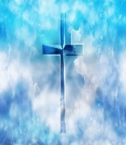  What does it mean to be a Christian in Britain today? | Why is Jesus inspiring to some people?  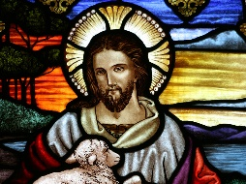 | What can we learn about deciding what is right and wrong? | What does it mean to be a Hindu in Britain today?
Aspects | In this unit children will learn to:  . Identify and name examples of what Christians have and do in their families and at church to show their faith.  . Ask good questions about what Christians do to show their faith.  . Describe some examples of what Christians do to show their faith, and make connections with some Christian beliefs and teachings.  . Describe some ways in which Christian express their faith through hymns and modern worship songs.  . Suggest at least two reasons why being a Christian is a good thing in Britain today, and two reasons why it might be hard sometimes.  . Discuss links between the actions of Christians in helping others and  . Explain similarities and differences between at least two different ways of worshipping in two different Christian churches.  ways in which people of other faiths and beliefs, including pupils | In this unit children will learn to:  . Ask questions raised by the stories and life of Jesus and followers today, and give examples of how Christians are inspired by Jesus.  . Suggest some ideas about good ways to treat others, arising from their learning.  . Make connections between some of Jesus’ teachings and the way Christians live today.  . Describe how Christians celebrate Holy Week and Easter Sunday.  . Identify the most important parts of Easter for Christians and say why they are important.  . Give simple definitions of some key Christian terms (e.g. gospel, incarnation, salvation) and illustrate them with events from Holy Week and Easter.  . Make connections between the Easter story of Jesus and the wider ‘big story’ of the Bible (creation, the Fall, incarnation, salvation) - connections with previous learning. | In this unit children will learn to:  Explore teachings which act as guides for living within Judaism, Christianity, and  a non‐religious belief system, e.g. the Ten Commandments (Exodus 20:1–21,  Deuteronomy 5:1–22), the Two Commandments of Jesus (Mark 12:28–34), the  golden rule for Humanists. What difference would it make if people keep these  guides for living?  • Use religious stories to explore the idea of temptation, and how it affects how  people choose between good and bad, e.g. in Christianity, use Genesis 3 and the  ‘Fall’, and Jesus resisting temptation in Matthew 4.  Talk about how pupils learn the difference between right and wrong. Is it always  clear? How do people know? Sometimes the commands or guidance from  religions help people to work out what the right thing is. Consider how helpful it  is to have guidance like this for making choices and decisions in everyday life. Is  it sometimes difficult for believers to follow the guidance? If religions say that  God inspires their rules for living, where do Humanists look for guidance?  Explore the lives of some inspirational religious individuals (e.g. Desmond Tutu,  Martin Luther King Jr). Consider how their religious faith inspired and guided  them in their lives. | In this unit children will learn to:  . Identify and name examples of what Hindus have and do in their families and at mandir to show their faith.  . Ask good questions about what Hindus do to show their faith.  . Describe some examples of what Hindus do to show their faith, and make connections with some Hindu beliefs and teachings about aims and duties in life.  . Describe some ways in which Hindus express their faith through puja, aarti and bhajans.  . Suggest at least two reasons why being a Hindu is a good thing in Britain today, and two reasons why it might be hard sometimes.  . Discuss links between the actions of Hindus in helping others and ways in which people of other faiths and beliefs, including pupils themselves, help others.  . Explain similarities and differences between Hindu worship and worship in another religious tradition pupils have been taught.
Key Vocabulary | God  Allah  Trinity  Holy Spirit  Moses  Trimurti  Vishnu  Shiva | Bible  Christian  creation  gospels  humanity  incarceration  prayer  salvation  scripture  sinner  wisdom | Christian  Dilemma  Faith  Humanist  Morals  Temptation  Ten Commandments | Rama  Dharma  Deity  Mandir  Diwali  Hindu  Puja  Ramayana  Shrine  Dharma  Deity  Mandir  Diwali
RE Skills
Investigation – this includes: asking relevant questions; knowing how to use a variety of sources in order to gather information; knowing what may count as good evidence in understanding religion(s).
Reflection – this includes: the ability to reflect on feelings, experience, attitudes, beliefs, values, relationships, practices and ultimate questions.
Empathy – this includes: developing the power of imagination to identify feelings such as love, wonder, forgiveness and sorrow; the ability to consider the thoughts, feelings, experiences, attitudes, beliefs and values of others; the ability to see the world through the eyes of others, and to see issues from their point of view.
Evaluation – this includes: the ability to debate issues of religious significance with reference to evidence, argument, opinion and statements of faith; weighing the respective claims of self-interest, consideration for others, religious teaching and individual conscience.
Expression – this includes: the ability to articulate ideas, beliefs and values; the ability to respond to religious ideas, beliefs and questions through a variety of media.
Self-understanding – this includes: the ability to draw meaning from significant experiences in their own and others’ lives and from religious questions and answers.

Year 4
 | RE 1 | RE 2 | RE 3 | RE 4
Overview | What do different people believe about God? | Why is the bible important to Christians today?  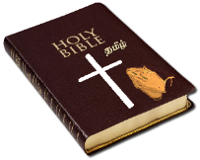 | 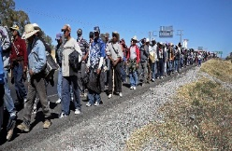  Why do some people think that life is a journey? | 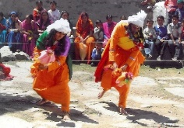  Why are festivals important to religious communities?
Aspects | In this unit children will learn to:  Talk about ways in which we exercise trust and faith in our everyday lives, linking to the idea of believing in God.  Find some examples of how we know about something we have not seen or experienced for ourselves.  Consider the question: What do people believe about God?  Explore some of the ways in which Christianity expresses ideas about God, including how Christians think of God as Trinity – Father, Son and Holy Spirit; how Christian create art expressing ideas about God, how Christians reflect on biblical  stories to develop ideas about God and how religious experiences help believers to understand God.  Explore some of the ways in which Islam expresses ideas about Allah / God including how Muslims use the 99 Names of Allah; calligraphy to express ideas, stories which help Muslims understand the nature of God e.g. the story of first revelation of the Qur’an to Prophet Muhammad [PBUH].  Explore the influence believing in God has on the lives of believers.  Explore the fact that many people do not believe in God. | In this unit children will learn to:  . Recall and name some Bible stories that inspire Christians.  . Identify at least two ways Christians use the Bible in everyday life.  . Make connections between stories in the Bible and what Christians believe about creation, the Fall and salvation.  . Give examples of how and suggest reasons why Christians use the Bible today.  . Describe some ways Christians say God is like, with examples from the Bible, using different forms of expression.  . Discuss their own and others’ ideas about why humans do bad things and how people try to put things right.  . Explain how the Bible uses different kinds of stories to tell a big story. | In this unit children will learn to Recall and name some of the ways religions mark milestones of commitment (including marriage).  . Identify at least two promises made by believers at these ceremonies and say why they are important.  . Suggest why some people see life as a journey and identify some of the key milestones on this journey.  . Describe what happens in Christian, Jewish, and/or Hindu ceremonies of commitment and say what these rituals mean.  . Suggest reasons why marking the milestones of life are important to Christians, Hindus and/or Jewish people).  . Link up some questions and answers about how believers show commitment with their own ideas about community, belonging and belief.  . Explain similarities and differences between ceremonies of commitment.  : | In this unit children will learn to:  . Recognise and identify some differences between religious festivals and other types of celebrations.  . Retell some stories behind festivals (e.g. Christmas, Divali, Pesach).  . Make connections between stories, symbols and beliefs with what happens in at least two festivals.  . Ask questions and give ideas about what matters most to believers in festivals (e.g. Easter, Eid).  . Identify similarities and differences in the way festivals are celebrated within and between religion.  . Explore and suggest ideas about what is worth celebrating and remembering in religious communities and in their own lives.  . Discuss and present their own responses about the role of festivals in the life of Britain today, showing their understanding of the values and beliefs at the heart of each festival studied, using a variety of media.  . Suggest how and why religious festivals are valuable to many people.
Key Vocab | Baptism  Bar Mitzvah  Bat Mitzvah  Ceremony  Chayil  commitment  communion  confession  confirmation  Humanist  journey  marriage  pilgrimage | Diwali  faith  Gayatri Mantra  Hindu  Mandir  mediate  mediation  shrine  spiritual  surah | crucifiction  Easter  gospel  inspire  symbol  resurrection  sin  athiests  parable  inspirational | aarti  aartha  bhajans  brahma  deities  dharma  kama  karma  mandir  moksha  murtis  puja  Trimurti
RE Skills

Investigation – this includes: asking relevant questions; knowing how to use a variety of sources in order to gather information; knowing what may count as good evidence in understanding religion(s).
Interpretation – this includes: the ability to draw meaning from artefacts, works of art, poetry and symbolism; the ability to interpret religious language; the ability to suggest meanings of religious texts.
Reflection – this includes: the ability to reflect on feelings, experience, attitudes, beliefs, values, relationships, practices and ultimate questions.
Empathy – this includes: developing the power of imagination to identify feelings such as love, wonder, forgiveness and sorrow; the ability to consider the thoughts, feelings, experiences, attitudes, beliefs and values of others; the ability to see the world through the eyes of others, and to see issues from their point of view.
Evaluation – this includes: the ability to debate issues of religious significance with reference to evidence, argument, opinion and statements of faith; weighing the respective claims of self-interest, consideration for others, religious teaching and individual conscience.
Application – this includes: making links between religion and individual, community, national and international life; identifying key religious values and their links with secular values.
Expression – this includes: the ability to articulate ideas, beliefs and values; the ability to respond to religious ideas, beliefs and questions through a variety of media.
Self-understanding – this includes: the ability to draw meaning from significant experiences in their own and others’ lives and from religious questions and answers.

Year 5
 | RE 1 | RE 2 | RE 3 | RE 4
Overview | Why do some people believe God exists? | What would Jesus do? | If God is everywhere, why go to places of worship? | What does it mean to be a Muslim in Britain today?  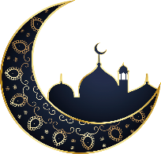
Aspects | In this unit children will learn to:  . Define the terms theist, atheist and agnostic and give examples of statements that reflect these beliefs.  . Give two reasons why a Christian believes in God and one why an atheist does not.  . Outline clearly a Christian understanding of what God is like, using examples and evidence.  . Give examples of ways in which believing in God is valuable in the lives of Christians, and ways in which it can be challenging.  . Express thoughtful ideas about the impact of believing or not believing in God on someone’s life.  . Present different views on why people believe in God or not, including their own ideas.  . Explain how Christians sometimes disagree about what God is like, giving examples of how they interpret texts differently. | In this unit children will learn to:  . Make connections between some of Jesus’ teachings and the way Christians live today.  . Discuss their own ideas about the importance of values to live by, comparing them to Christian ideas.  . Outline Jesus’ teaching on how his followers should live.  . Offer interpretations of two of Jesus’ parables and say what they might teach Christians about how to live.  . Explain the impact Jesus’ example and teachings might have on Christians today.  . Express their own understanding of what Jesus would do in relation to a moral dilemma from the world today.  . Explain the links between Jesus’ death on the cross and Christian belief in love and forgiveness, giving reasons why Christians want to follow Jesus | In this unit children will learn to:  . Recall and name some key features of places of worship studied.  . Find out about what believers say about their places of worship.  . Make connections between how believers feel about places of worship in different traditions.  . Select and describe the most important functions of a place of worship for the community (B3).  . Give examples of how places of worship support believers in difficult times, explaining why this matters to believers.  . Present ideas about the importance of people in a place of worship, rather than the place itself.  . Outline how and why places of worship fulfil special functions in the lives of believers | In this unit children will learn to:  . Describe the Five Pillars of Islam and give examples of how these affect the everyday lives of Muslims.  . Identify three reasons why the Holy Qur’an is important to Muslims, and how it makes a difference to how they live.  . Make connections between Muslim practice of the Five Pillars and their beliefs about God and the Prophet Muhammad.  . Describe and reflect on the significance of the Holy Qur’an to Muslims.  . Describe the forms of guidance a Muslim uses and compare them to forms of guidance experienced by the pupils.  . Make connections between the key functions of the mosque and the beliefs of Muslims.  . Comment thoughtfully on the value and purpose of religious practices and rituals in a Muslim’s daily life
Key Vocabulary | atheist  agnostic  beliefs  evolution  facts  interpretation  opinions  theist  universe | beatitudes  bible  dilemma  follower  generosity  greed  justice  moral  mount  parable  sermon  sermon on the  values  Samaritan | Anglican  Baptist  mandir  worship  shrine  sadhus  shakira  synagogue  schul  bimah | Allah  Mecca  mosque  pilgrimage  Ramadan  Qur’an  rak’ah  Ummah  sawm  zakat  hajj  sakat
RE Skills
Investigation – this includes: asking relevant questions; knowing how to use a variety of sources in order to gather information; knowing what may count as good evidence in understanding religion(s).
Interpretation – this includes: the ability to draw meaning from artefacts, works of art, poetry and symbolism; the ability to interpret religious language; the ability to suggest meanings of religious texts.
Reflection – this includes: the ability to reflect on feelings, experience, attitudes, beliefs, values, relationships, practices and ultimate questions.
Empathy – this includes: developing the power of imagination to identify feelings such as love, wonder, forgiveness and sorrow; the ability to consider the thoughts, feelings, experiences, attitudes, beliefs and values of others; the ability to see the world through the eyes of others, and to see issues from their point of view.
Evaluation – this includes: the ability to debate issues of religious significance with reference to evidence, argument, opinion and statements of faith; weighing the respective claims of self-interest, consideration for others, religious teaching and individual conscience.
Analysis – this includes: distinguishing between opinion, belief and fact; recognizing bias, caricature, prejudice and stereotyping; distinguishing between the features of different religions.
Application – this includes: making links between religion and individual, community, national and international life; identifying key religious values and their links with secular values.
Expression – this includes: the ability to articulate ideas, beliefs and values; the ability to respond to religious ideas, beliefs and questions through a variety of media.
Self-understanding – this includes: the ability to draw meaning from significant experiences in their own and others’ lives and from religious questions and answers.

Year 6
 | RE 1 | RE 2 | RE 3 | RE 4
Overview | What can be done to reduce racism Can religion help? | Is it better to express your religion through art and architecture or charity and generosity?  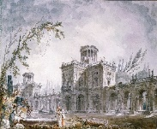 | What difference does it make to believe in Ahimsa, Grace and Ummah? | What matters most to Christians and Humanists?  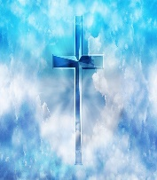
Aspects | In this unit children will learn to:  . Discover and think about the meanings of some key ideas about racism and religion by studying some people who have given their lives to reducing prejudice and hatred.  Learn in depth and detail about the statues of Colston and Wesley in Bristol.  Consider how music, film, prayer, art and other forms of expression have been used in struggles against racism. Enable pupils to think for themselves about the ways that scriptures encourage religious people to treat all humans with dignity, respect, equity or love – and consider reasons why this does not always happen.  Learn that early Christian traditions include important stories about human unity, even though the Christian church has sometimes been complicit in racism. Learn that Prophet Muhammad taught his followers to set racial difference aside.  Ask good questions about racism and equality, discussing how religion could make more positive contributions to justice.  Consider some questions, such as: can prayer help reduce racism? Does God care about racism? Why are religious people sometimes racist even though they preach love for all? Is it only religious people who fail to live up to their ideals?  Create a work of art and commentary on it, expressing pupils’ reactions to the idea that ‘we have far more in common than keeps us apart’.  Pupils weigh up their own learning in relation to their own ideas about equity, | In this unit children will learn to:  . Respond with ideas of their own to the title question.  . Find out about religious teachings, charities and ways of expressing generosity.  . Describe and make connections between examples of religious creativity (buildings and art).  . Show understanding of the value of sacred buildings and art.  . Suggest reasons why some believers see generosity and charity as more important than buildings and art.  . Apply ideas about values and from scriptures to the title question.  . Outline how and why some Humanists criticise spending on religious buildings or art. | In this unit children will learn to:  . Describe what Ahimsa, Grace or Ummah mean to religious people.  . Respond sensitively to examples of religious practice with ideas of their own.  . Make connections between beliefs and behaviour in different religions.  . Outline the challenges of being a Hindu, Christian or Muslim in Britain today.  . Make connections between belief in ahimsa, grace and Ummah, teachings and sources of wisdom in the three religions.  . Consider similarities and differences between beliefs and behaviour in different faiths.  . Explain similarities in ways in which key beliefs make a difference to life in two or three religions | In this unit children will learn to:  . Identify the values found in stories and texts.  . Suggest ideas about why humans can be both good and bad, making links with Christian ideas.  . Describe what Christians mean about humans being made in the image of God and being ‘fallen’, giving examples.  . Describe some Christian and Humanist values simply.  . Express their own ideas about some big moral concepts, such as fairness, honesty etc., comparing them with the ideas of others they have studied.  . Suggest reasons why it might be helpful to follow a moral code and why it might be difficult, offering different points of view.  . Give examples of similarities and differences between Christian and Humanist values.
Key Vocabulary | Fairness  Prejudice  Racism  Ethnicity  Justice  Hate speech  White privilege  Tolerance  Sensitivity  Respect  Acceptance | architecture  calligraphy  charity  generosity  holy  sacred  scripture  symbols  teaching  wealth | ahimsa  believe  Hajj  Makkah  pilgrimage  prophet  Quirbani  Sewa  Zaket | code  consequence  fairness  fellowship  forgiveness  Humanist  moral dilemma  peacemaker  values
RE Skills
Investigation – this includes: asking relevant questions; knowing how to use a variety of sources in order to gather information; knowing what may count as good evidence in understanding religion(s).
Interpretation – this includes: the ability to draw meaning from artefacts, works of art, poetry and symbolism; the ability to interpret religious language; the ability to suggest meanings of religious texts.
Reflection – this includes: the ability to reflect on feelings, experience, attitudes, beliefs, values, relationships, practices and ultimate questions.
Empathy – this includes: developing the power of imagination to identify feelings such as love, wonder, forgiveness and sorrow; the ability to consider the thoughts, feelings, experiences, attitudes, beliefs and values of others; the ability to see the world through the eyes of others, and to see issues from their point of view.
Evaluation – this includes: the ability to debate issues of religious significance with reference to evidence, argument, opinion and statements of faith; weighing the respective claims of self-interest, consideration for others, religious teaching and individual conscience.
Analysis – this includes: distinguishing between opinion, belief and fact; recognizing bias, caricature, prejudice and stereotyping; distinguishing between the features of different religions.
Synthesis – this includes: linking significant features of religion(s) together in a coherent pattern; connecting different aspects of life into a meaningful whole.
Application – this includes: making links between religion and individual, community, national and international life; identifying key religious values and their links with secular values.
Expression – this includes: the ability to articulate ideas, beliefs and values; the ability to respond to religious ideas, beliefs and questions through a variety of media.
Self-understanding – this includes: the ability to draw meaning from significant experiences in their own and others’ lives and from religious questions and answers.

