Netherton J&I

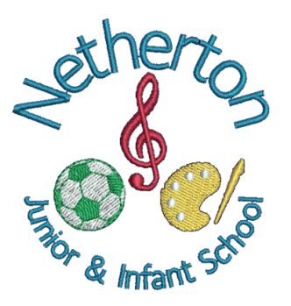

Safer eating policy 2025
Safer Eating Policy for Early Years at Netherton J&I

Safer Eating Policy for Early Years at Netherton J&I

1. Purpose of the Policy
This policy ensures that all children in our Early Years setting eat safely, reducing risks of choking, allergic reactions, foodborne illness, and unsafe eating practices. It supports statutory safeguarding and health requirements.

2. Roles and Responsibilities

Staff:
- Supervise children closely during all eating and drinking times.
- Prepare and serve food safely according to food hygiene guidance.
- Follow individual dietary requirements and allergy management plans.
- Model safe eating behaviours (e.g., sitting when eating).
- Report and record any incidents such as choking, allergic reaction, or food refusal.

Families:
- Provide accurate, up-to-date information about allergies, intolerances, and dietary preferences.
- Supply packed lunches or snacks that meet the setting’s safety and nutrition guidelines.
- Inform the setting of any changes to dietary needs immediately.

Management:
- Ensure staff receive regular training in food safety, choking prevention, and allergy awareness.
- Maintain safe food storage, preparation, and hygiene practices.
- Review and update children’s dietary and medical records.

3. Choking Prevention and Safe Eating Practices
- Children must sit down while eating or drinking.
- Staff maintain constant, face-to-face supervision during mealtimes.
- Food will be cut into safe sizes:
* Grapes, cherry tomatoes, blueberries → halved lengthways
* Sausages → cut into thin strips
- No whole nuts or popcorn are permitted.
- Children are encouraged to eat slowly, take small bites, and avoid talking with food in their mouths.
- Staff check for removable hazards such as loose clothing cords.

4. Allergy and Dietary Requirements
- The setting maintains an Allergy Register with photos of children and allergen details.
- All staff read and sign the register and follow it at every meal.
- Allergen-free meals/snacks are prepared separately with separate equipment.
- Staff never introduce new foods to a child with known allergies without written parental consent.
- Emergency plans (e.g., for anaphylaxis) are displayed in relevant areas.
- Medication such as EpiPens must be easily accessible and checked regularly.

5. Food Hygiene and Preparation
- Staff follow Level 2 Food Safety training principles.
- Hands are washed before preparing or serving food.
- Children wash their hands before every mealtime.
- All food is stored at safe temperatures and checked for expiry.
- Surfaces, utensils, and equipment are sanitised before and after use.
- Hot food is checked to ensure it is at a safe serving temperature.

6. Mealtime Environment
- Calm, unhurried atmosphere with opportunities for conversation.
- Suitable furniture ensuring children can sit upright and safely.
- Age-appropriate cutlery and cups.
- Staff encourage independence while maintaining safety.

7. Managing Packed Lunches
- Parents are advised to avoid high-choking-risk foods unless cut safely.
- No food containing common allergens (e.g., nuts) if the setting has a no-nut policy.
- All packed lunch items must be labelled.
- Staff will remove any unsafe items and inform parents.

8. Incident Management
- Staff are trained in paediatric first aid, including choking response.
- Any choking, allergic reaction, or significant food-related incident is managed immediately, recorded, reported to parents/carers, and reviewed.

9. Training and Review
- Annual staff training on choking prevention, allergies, and food safety.
- Policy reviewed annually or sooner if guidance changes or following an incident.

