Poetry Spine – Netherton Junior & Infant School
Poetry Progression 2024 - 2025
“The Poetry Spine is designed to ensure that each term children become familiar with at least one key poet. A simple way to ensure poetry becomes a regular feature of the curriculum is to establish a ‘poem of the week’ system. You can supplement this by listening to poets reading their work. Ensuring that children have poetry read to them on a regular basis over the years increases their familiarity with poetry’s many possibilities.” Pie Corbett, Literacy expert
EYFS & KS1 | EYFS 1 & 2 |  | Year 1 | Year 2
Reading Poetry | Action Rhymes  Nursery Rhymes  Counting Rhymes  Rhyming stories  Rhythmic poems and patterned poems that feature alliteration and word play. |  | Develop pleasure in reading, motivation to read, vocabulary and understanding by:  •listening to and discussing a wide range of poems, stories and non-fiction at a level beyond that at which they can read independently  •recognising and joining in with predictable phrases  •learning to appreciate rhymes and poems, and to recite some by heart  •discussing word meanings, linking new meanings to those already known  •understand both the books they can already read accurately and fluently and those they listen to by:  •drawing on what they already know or on background information and vocabulary provided by the teacher  •checking that the text makes sense to them as they read, and correcting inaccurate reading  •discussing the significance of the title and events  •making inferences based on what is being said and done. | Develop pleasure in reading, motivation to read, vocabulary and understanding by:  - listening to, discussing and expressing views about a wide range of contemporary and classic poetry,  - recognising simple recurring literary language in stories and poetry  - discussing and clarifying the meanings of words, linking new meanings to known vocabulary  - discussing their favourite words and phrases  - continuing to build up a repertoire of poems learnt by heart, appreciating these and reciting some, with appropriate intonation to make the meaning clear  understand both the books that they can already read accurately and fluently and those that they listen to by:  - drawing on what they already know or on background information and vocabulary provided by the teacher  - checking that the text makes sense to them as they read, and correcting inaccurate reading  - making inferences on the basis of what is being said and done  - answering and asking questions  - predicting what might happen on the basis of what has been read so far  participate in discussion about books, poems and other works that are read to them and those that they can read for themselves, taking turns and listening to what others say
Texts/Resources | Suggested Books  Tanka, Tanka Skunk  Pass the Jam Jim  Bear Hunt  Any by Julia Donaldson  Shirley Hughes seasonal poetry  Poetry Spine books:  Here’s a Little Poem  Sharing a Shell  My Many Coloured Days  A treasury of Songs Books |  | Poems about senses  Poems about seasons  Poems and rhyming stories with patterns and repetitions  Suggested Books – Including classic poetry  Any by Dr Seuss  The Lion Inside  The Koala Who Could  Any by Julia Donaldson  Shirley Hughes seasonal poetry  Poetry Spine Books:  Hey Little Bug  When we were young  The Puffin Book of Fantastic First Poems  Here’s a Little Poem | Humorous / Nonsense Verse  Word play poems  Poems with descriptive language e.g. colour poems, poems about the seasons  Poems based on close observation of the natural world.  Suggested Books - Including classic poetry  The Language of cat  Animal Magic  A Caribbean Dozen  Noisy Poems  Roald Dahl Revolting rhymes  Poetry Spine Books:  Crazy Mayonnaisy Mum  The Works Key Stage 1  A First Poetry Book  Heard it in the playground
Performing Poetry | Join in with, copy and perform action songs and rhymes – including nursery rhymes.  Move to strongly rhythmic songs and rhymes  Tap out the rhythm of individual words and phrases e.g caterpillar, Sea,Sea,Sea. |  | Create own action to go with poems.  Watch poets perform online e.g. Michael Rosen  Encourage small group performances of poems learnt by heart. | Paired / individual performances  Add own sound effects to a poem e.g. The Sound Collector
Texts / Resources | Miss Poly  Hot Cross Buns  One, Two Buckle My Shoe  Caribbean Counting Poem – Pamela Mordecai  The Dark Wood - anon |  | There Was an Old Lady Who Swallowed a Fly  Voices of Water – Tony Mitton  My Colours Colin West  Hands – Julia Donaldson  Queue for the Zoo – Clare Bevan | I’m Walking with my Iguana – Brian Moses  Solo with Chorus – Rose Fyleman  The Rhythm of Life – Michael Rosen  Nut Tree – Julia Donaldson  The Dinosaur Rap – John Foster  Cats – Eleanor Farjeon  Shhhhhh! – Julia Donaldson
Writing Poetry | Create group / class poems which are modelled by the teacher, using the children’s ideas.  Alliteration strings.  Silly/Funny sentences.  Simple poems based on experience e.g. I went to the park and I saw:… |  | Write simple rhyming strings and couplets  Invent alliterative tongue twisters  Non-rhyming poems based on personal experience – e.g. fireworks  Write a poem based on close observation of a natural object | N.C Objective  develop positive attitudes towards and stamina for writing by:  - writing about real events  writing poetry
Texts & Resources | Silly sentences  Aliteration strings  Centipede Nursery Rhyme.  Tiny Caterpillar Rhyme.  Shoo-Fly.  The Ants Go Marching.  Incy Wincy Spider  Twinkl link below  Alphabet Poem – Michael Rosen  Pineapple – Vyanne Samuel |  | Acrostic poems  - Friends – John P. Read  - A Family – Patricia Biddle  - Pumpkin – Kaitlyn Guenther  - B – Is For Birthday- Erika L  Funny Poems – Luke J  Writing poems about the seasons/festivals/celebrations.  Templates available on Twinkl  Fireworks – Gervais Phinn  Christmas - Gervais Phinn | Shape Poems  What is he? – Liz Brownlee  The Shape of a poem – Chris Odgen  Aaaah!!!! At last it’s Spring – James Carter  Family Tree – Damien Harvey  Word Whirls – John Foster  Templates available on Twinkl
Vocabulary | Nursery Rhyme Sound  Word Sentence  Beat Poem  Rhyme Letter |  | EYFS list plus  List poem  Nonsense poem  Repetition  Pattern  Acrostic | EYFS and Year 1 list plus  Metaphor  Personification  Limerick  Acrostic
Websites | https://www.poetry4kids.com/news/writing-riddles/  https://poemsideas.blogspot.com/2020/06/77-elegant-famous-acrostic-poems-for.html  https://www.youngwriters.co.uk/info/other/poetry-terms/kenning  https://www.kidzone.ws/poetry/acrostic.htm  https://www.twinkl.co.uk/resources/literacy-eyfs-early-years/early-years-writing/early-years-poetry  https://www.bbc.co.uk/bitesize/topics/z4mmn39 poetry videos  https://www.booktrust.org.uk/what-we-do/childrens-laureate/former-laureates/michael-rosen/poetry-resources-and-ideas-for-teachers/  https://www.readingandwritinghaven.com/six-simple-ways-to-make-poetry-instruction-engaging
Intention for all age ranges | Children will be read poetry weekly using the progression planning above. Choose a day and time which will be least disrupted and make it non-negotiable. Read more if you can or simple learn a poem to sing each day!  Each class has an allocated poetry spine of books that will be specific to that year group to use.  Please focus in on the author and have a discussion/research about them so the children will build up their knowledge of poets.  If possible, create a display within your reading corners or walls of the current poet and poem you are studying.  Add vocabulary used and found within poems to the poetry area so children can apply it in their writing and build up their word banks.  I have included all the National Curriculum objectives where applicable so these will need to be met.  Evidence of these objective can be recorded in writing or reading books. Memory books will be a good source of evidence for the performance poetry.  The planning does not all have to be completed. I have included a wealth of poets/books/poems/songs so that you have a good variation to choose from.  I have included a number of websites that will support you in teaching and reading poetry to your class. There are some fantastic ideas.
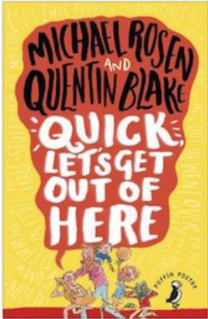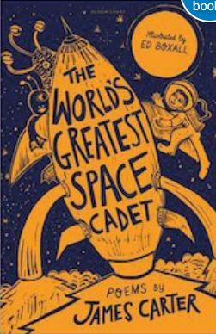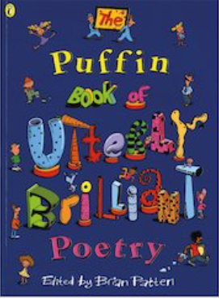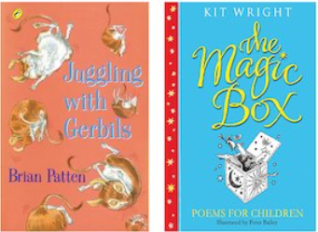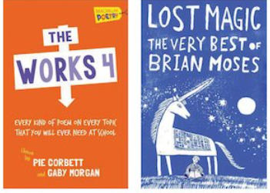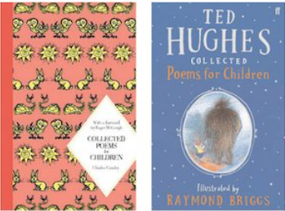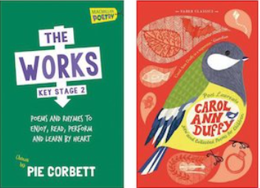
KS2 | Year 3 & 4 |  | Year 5 | Year 6
Reading Poetry | Develop positive attitudes to reading, and an understanding of what they read, by:  - listening to and discussing a wide range of fiction, poetry, plays, non-fiction and reference books or textbooks  - preparing poems and play scripts to read aloud and to perform, showing understanding through intonation, tone, volume and action  - discussing words and phrases that capture the reader’s interest and imagination  recognising some different forms of poetry [for example, free verse, narrative poetry]  understand what they read, in books they can read independently, by:  - checking that the text makes sense to them, discussing their understanding, and explaining the meaning of words in context  - asking questions to improve their understanding of a text  - drawing inferences such as inferring characters’ feelings, thoughts and motives from their actions, and justifying inferences with evidence |  | By the beginning of year 5, pupils should be able to read aloud a wider range of poetry and books written at an age-appropriate interest level with accuracy and at a reasonable speaking pace.  Pupils’ knowledge of language, gained from stories, plays, poetry, non-fiction and textbooks, will support their increasing fluency as readers, their facility as writers, and their comprehension.  Maintain positive attitudes to reading and an understanding of what they read by:  - continuing to read and discuss an increasingly wide range of fiction, poetry, plays, non-fiction and reference books or textbooks  - learning a wider range of poetry by heart  - preparing poems and plays to read aloud and to perform, showing understanding through intonation, tone and volume so that the meaning is clear to an audience  Understand what they read by:  - checking that the book makes sense to them, discussing their understanding and exploring the meaning of words in context  - asking questions to improve their understanding  - drawing inferences such as inferring characters’ feelings, thoughts and motives from their actions, and justifying inferences with evidence  - predicting what might happen from details stated and implied  - Identifying how language, structure and presentation contribute to meaning  - discuss and evaluate how authors use language, including figurative language, considering the impact on the reader. | By the end of year 6, pupils’ reading and writing should be sufficiently fluent and effortless for them to manage the general demands of the curriculum in year 7, across all subjects and not just in English, but there will continue to be a need for pupils to learn subject-specific vocabulary. They should be able to reflect their understanding of the audience for and purpose of their writing by selecting appropriate vocabulary and grammar.  Pupils’ knowledge of language, gained from stories, plays, poetry, non-fiction and textbooks, will support their increasing fluency as readers, their facility as writers, and their comprehension.  Maintain positive attitudes to reading and an understanding of what they read by:  - continuing to read and discuss an increasingly wide range of fiction, poetry, plays, non-fiction and reference books or textbooks  - learning a wider range of poetry by heart  - preparing poems and plays to read aloud and to perform, showing understanding through intonation, tone and volume so that the meaning is clear to an audience  Understand what they read by:  - checking that the book makes sense to them, discussing their understanding and exploring the meaning of words in context  - asking questions to improve their understanding  - drawing inferences such as inferring characters’ feelings, thoughts and motives from their actions, and justifying inferences with evidence  - predicting what might happen from details stated and implied  - Identifying how language, structure and presentation contribute to meaning
Texts & Resources | Narrative with Rhyme  Scared – Michael Rosen  The Listeners – Walter de la Mer  Quick Let’s Get Out Of Here  The World’s Greatest Space Cadet | Narrative with Rhyme  The Sound Collector – Roger McGough  Poetry Spine Books  The Puffin Book Of Utterly Brilliant Poetry  Juggling with Gerbils  The Works 4 | Poetry Spine Books  The Lost Magic. The very best of Brian Moses  The Magic Box | Poetry Spine Books  Ted Huges Collected Poems For Children  Charles Causley: Collected Poems For Children  The Works KS2  Carol Ann Duffy: New and Collected Poems For Children
Performing Poetry | Paired / individual/group performances  Add own sound effects to a poem using own body parts  Create a dance or movement to a poem. |  | NC: Perform their own compositions, using appropriate intonation, volume, and movement so that meaning is clear  Paired / individual/group performances  Add own sound effects to a poem using own body parts/instruments  Create a dance or movement to a poem.  Use intonation and prosody to bring about emotion when reading aloud. | NC: Perform their own compositions, using appropriate intonation, volume, and movement so that meaning is clear  Paired / individual/group performances  Add own sound effects to a poem using own body parts/instruments  Create a dance or movement to a poem.  Use intonation and prosody to bring about emotion when reading aloud.
Texts & Resources | Instructions for Giants – John Rice  Twenty Four Hours – Charles Causley | Life doesn’t Frighten me at all – Mya Angelou  The Sound Collector – Roger Mc Gough | Macavity by T.S Eliot  The Treasures – Clare Bevan  Today, I feel – Gervais Phinn  The Trouble with My Brother – Brian Patten  You Can’t Stop me – Miriam Moss  Give and Take – Roger Mc Gough  From a Railway Carriage – R.L Stevenson  Conversation Piece – Gareth Owen  Football Mad – Benjamin Zephaniah  Rum Tum Tiger – T.S Eliot | The Visitor - Ian Serrailler  Cargoes - John Masefield  The Lion and Albert - Marriot Edgar  If - Rudyard Kippling  The Jumblies - Edward Lear  What I Love About School – Roger Mc Gough
Writing Poetry | Haiku Poems  A haiku is a form of poem that originates from Japan. A haiku has three lines. There can be any number of words, but there must be 5 syllables in the first line, 7 syllables in the second line and 5 syllables in the third line. Haikus do not usually rhyme. | Tanka Poems  Tanka poetry refers to a Japanese 31-syllable poem, traditionally written as a single, unbroken line. The word tanka translates to "short song." Similar to haiku poetry, tanka poems have specific syllable requirements. | Simile and Metaphor Poems  Simile is common poetic device. The subject of the poem is described by comparing it to another object or subject, using 'as' or 'like'. For example, the subject may be 'creeping as quietly as a mouse' or be 'sly, like a fox.  A metaphor is a type of figurative language, often used in poetry or literary prose. It is, in simplest terms, a comparison. It forms a link between two unlike things by stating one thing is another. The big difference between a metaphor and a simile is that similes use the words 'like,' or 'as.  Cinquain  A cinquain poem is a five-line poem that does not rhyme. They can be written about whatever you like. The syllable pattern is 2, 4, 6, 8, 2. It is best to count the syllables and brainstorm ideas to help you follow the structure. | Blank Verse (classics)  Blank verse is a type of unrhymed poetry with a regular pattern of rhythm, or meter. It is written in iambic pentameter, meaning that each line is made of five pairs of unstressed/stressed syllables, for a total of 10 syllables.  Sonnets (classic)  A poem with 14 lines. There is a regular rhythm and a special pattern of rhymes. Some sonnets ask a question or set up a problem, which is answered or solved in the last two lines, or couplet.  Narrative (Classic)  A narrative poem is a type of poem that tells a story. Narrative poems tend to be quite long. They tell a story like in a novel and also use rhythm and rhyme, like in a poem.
Texts/Resources | Haiku  Seaview Haiku – John Foster  Windy Day – John Foster  Haiky Riddle – Celia Warren | Tanka  Silver aeroplane - John Foster  The Penny Black – John Foster  Two Tanka Riddles – Marian Swinger | Personification  Winter - Olivia Kooker  Snow and Snow - Ted Hughes  It’s Spring – John Foster  Jack Frost – C.E Pike  Similes/Metaphors  The Night Will Never Stay – Eleanor Farjeon  Bluebottle – Judith Nichols  Windrush child by John Agard  Cinquain  November Night- Adelaide Crapsey  Snow – Adelaide Crapsey  Winter - Adelaide Crapsey  Blackbird – John Foster  At the Gate – John Foster  The Wood in late Autumn – John Foster  Mirror – John Foster  How to Write Cinquains? – John Foster | Blank Verse  Mercutio's Queen Mab Monologue in Romeo and Juliet by William  Shakespeare.  The Mending Wall by Robert Frost  To be or not to be from Hamlet by William Shakespeare  Tintern Abbey William Wordsworth  The Princess by Alfred Lord Tennyson  Sonnets  Compare 2 classic sonnets for content, use of language and rhyme  pattern. E.g.  Summer-water Sonnet Gillian Clarke  Lines Upon Westminster Bridge by William Wordsworth  Narrative  The Highway Man – Alfred Noyse  The Owl and the Pussycat – Edward Lear  The Listeners by Walter De La Mare  The Pied Piper by Robert Browning  Matilda by Hillaire Belloc  The Tyger by William Blake  The Jabberwocky by Lewis Carroll  The Pillow book by Sei Shonagon  The Sick Rose by William Blake
Vocabulary | Simile  Riddle  Syllable  Haiku | Tanka  Projection  Prosody | Year ¾ list recap  Personification  Metaphor  Cinquain  Projection | Previous year group recap  Sonnet  Verse  Rhythm and Meter
Websites | https://www.kidzone.ws/poetry/haiku.htm  https://poetry4kids.com/lessons/how-to-write-a-tanka-poem/  https://childrens-books.lovetoknow.com/Examples_of_Metaphor_Poems_for_Children  https://www.bbc.co.uk/bitesize/topics/z4mmn39/articles/z3btrwx narrative poems  Further links above in KS1 and EYFS might well help to support the teaching of poetry.

