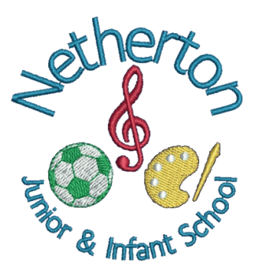 PTA FUNDING REQUEST FORM
The Friends of Netherton PTA is a registered charity and was established to advance the education of the pupils at Netherton Junior and Infant School. The PTA focuses on 1) developing effective relationships between the staff, parents and others associated with the school; and 2) engaging in activities or providing facilities or equipment which supports the school and advances the education of the pupils. These are known as the PTA’s charitable objectives.
The PTA must ensure that each and every funding commitment is made in the best interest of the charity and is a suitable use of the charity’s funds. For this reason, all funding requests should be made formally and via this form.
To request funds please return this form to the PTA.

Funding Requested – please provide details of the event, equipment, or activity you are looking to fund

Full Cost |  | PTA Cost | PTA % | Date funds are required
£ | £

Benefits – please provide a brief description of how the event/equipment/activity will advance the education of the pupils at the school

Pupil Impact (Please tick as applicable)
Pupil No
Please state number of students affected in each year
Year Group | EY1 | EY2 | YR1 | YR2 | YR3 | YR4 | YR5 | YR6 | Total

Requested by | Request Date
Signed

PTA COMMITTEE USE ONLY
Decision (Please tick as appropriate)
Approved | Declined | Deferred | Date of Decision
Are any Grants available?
Comments
PTA Chair |  | PTA Treasurer

Guidelines for PTA funding applications

Funds raised by the PTA are to enable the school to pay for events, activities or equipment outside the normal (core) school budget. This is to ensure that the education of children does not become reliant on PTA funds, which cannot be guaranteed.

In special circumstances, core items that would ordinarily be expected to be funded by the normal school budget could be approved for PTA funding. However, assurance from the head teacher must be acquired that provisions will be made within in the school budget for such items in the future.

The PTA committee wants to ensure that funds are spent in an effective way that will benefit and support the children; and we also try to ensure that funds are spread evenly across the key stages, different academic areas and extra-curricular activities and interests.

We want the funding application process to be as simple as possible, and wish to make children, parents/carers and staff aware of the following guidelines when applying for PTA funding.

A copy of the funding request form is available to download on the PTA section of the school website and should be passed to the PTA directly or via the school office. Each application will be considered at the next PTA meeting and needs to be approved by the PTA before funds are confirmed.

The PTA will keep a record of funds spent and will review their effectiveness over time to help make decisions about future funding applications. Each application will be considered on an individual basis, and successful applications should not be seen as setting a precedent.

